1. Team Directory

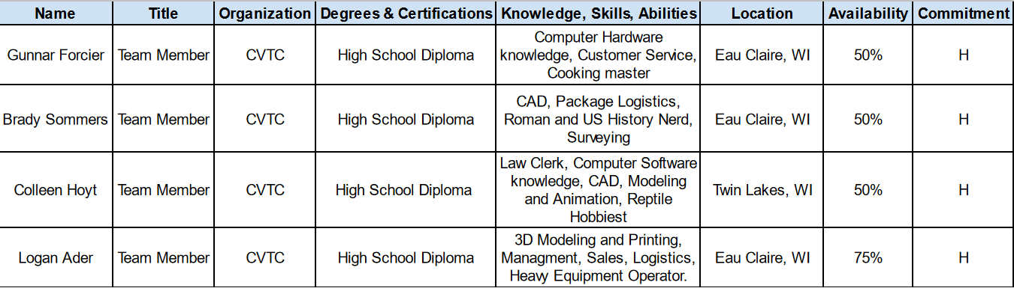

1. Raci Chart

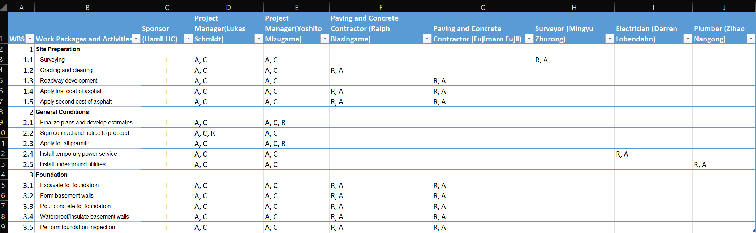

.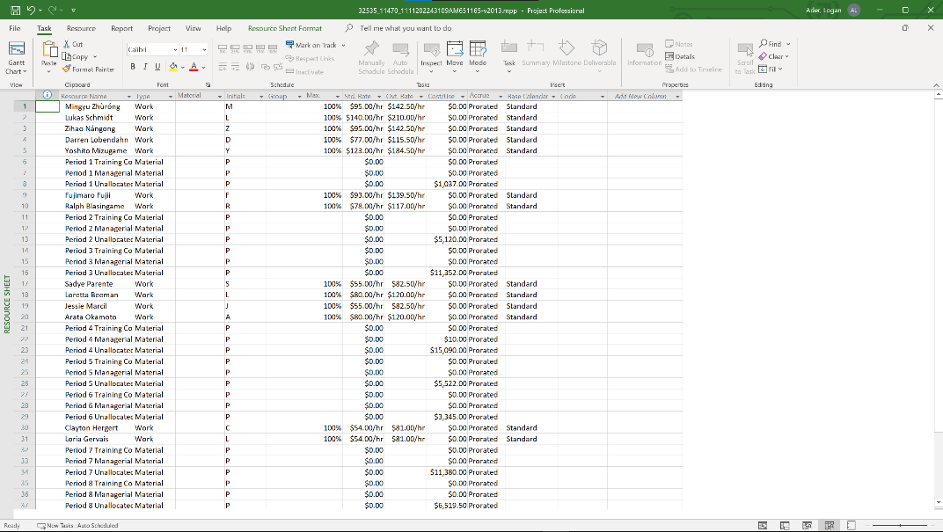

1. Resource Sheet

1. Network Diagram 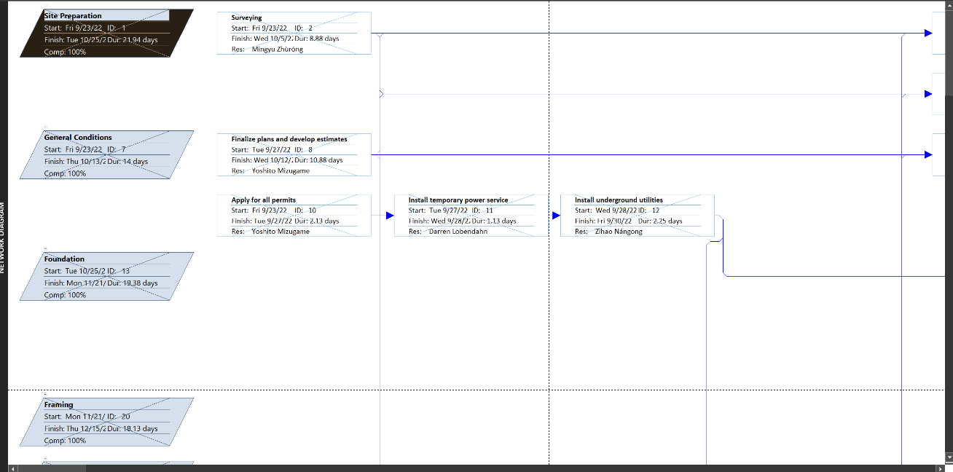
2. Cash Flow Report & Analysis

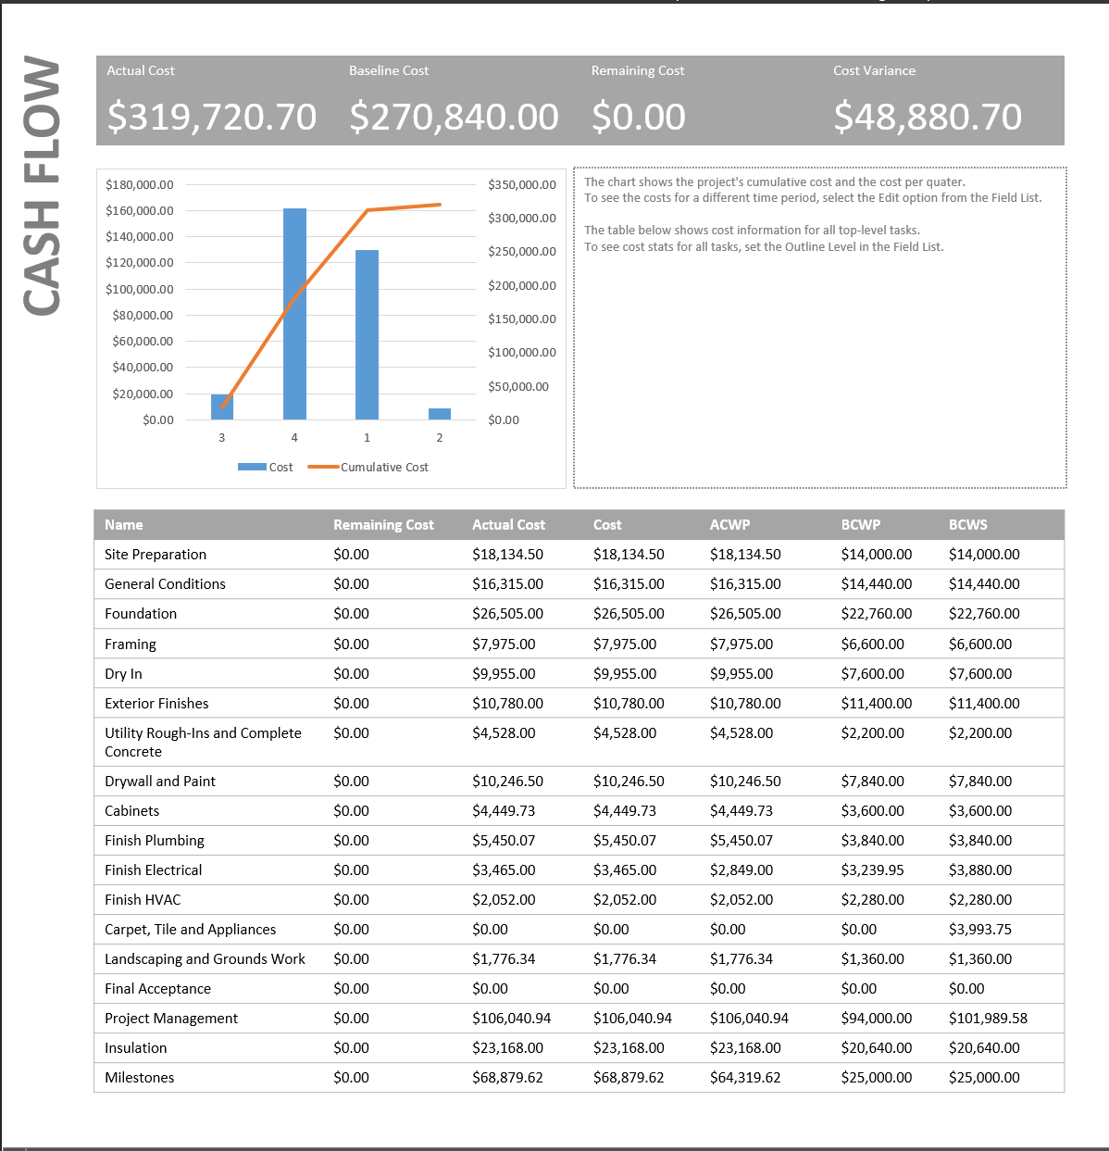

The cost variance is representative of the fact that 72% of the budgeted cost of work scheduled was underbudgeted and ended up with a higher actual cost. 28% of the BCWS had an Actual Cost that met the budgeted amount or came in below. Milestones for example had a budgeted cost of work scheduled at $25,000 and the actual cost is $68,880.